Your Name
Date
CIS 1513 Section 3 Hmwk

Section 3 Lesson 1 Try It / Solve It Questions below:

Try It / Solve It -- Here are some relationship lines and symbols u can copy & paste

1. Read the given business scenario. Draw the relationships between ORDER and WAITER, including the cardinality and optionality lines and symbols.

We assign our waiters to certain areas, except for our trainees, who just observe and are not responsible for taking any orders yet.
A waiter takes the orders for the tables in his/her area.
All areas have one assigned waiter.
A customer places an order with a waiter. If the customer has a question or wants to make a change to the order, he/she needs to request this with assigned waiter
WAITER
ORDER

Name 2 Relationship sentences between waiter and order:

A waiter __________ have _________ Orders.

An Order ________be from ________ Waiter.

2. Read the given business scenario. Name the relationships between PARENT and
CHILD. Include appropriate optionality and cardinality.

At the end of each day, parents need to pick up their children at our day-care center. All children must be picked up by 6 p.m.
A child may have two parents, but we need only one of them to come and pick up their child or children.
We cannot release a child to anyone but that child’s parents.
PARENT
CHILD

-

Name 2 Relationship sentences:

A Parent __________ pick up _________ Child/children.

A Child(children) ________ be picked up by ________ Parent.
3. Read the given business scenario. Draw the relationships between COURSES and STUDENT. Include appropriate optionality and cardinality.

Students at CNM may take one or many courses.
CNM Courses must have 12 or more students.

What type of Relationship is this? _________

Does further Normalization need to be done?___________

STUDENTS

COURSES

Section 3 Lesson 2 Try It / Solve Questions below:

- Read the given business scenario. Draw the entities HAIRSTYLIST and CLIENT. List the attributes associated with each entity and specify if they are mandatory/optional.
Identify the UIDs. Draw the relationship between the 2 entities. Including optionality and cardinality lines and symbols.

"In our salon, we have a number of hairstylists. They are all salaried employees, so we keep a record of their first name, last name, address, phone number, social-security number, and salary.
During the course of a day, a hairstylist may see several clients.
On a slow day, a hairstylist may not work on anyone at all.
We have several walk-in clients, and they each get assigned to one hairstylist.

We just ask for their first name. We also have customers who call to make an appointment. When they do this, we ask for their first name, last name, and phone number. We also ask if they would like a specific hairstylist. If they have no preference, we assign one for them.

Of course, they are allowed to switch to another hairstylist for their next visit.
We are interested in tracking the daily appointments -- which stylist works on which client during a given day and we would like other reports for our business.
HAIRSTYLIST
CLIENT

Name 2 Relationship sentences:

A Hairstylist __________ have _________ Client(s).

A Client ________ have their hair cut by ________ Hairstylist(s).
Section 3 Lesson 3 Try It / Solve It Questions below:

1. The goal of this practice is to read a relationship. Which text corresponds to the diagram?
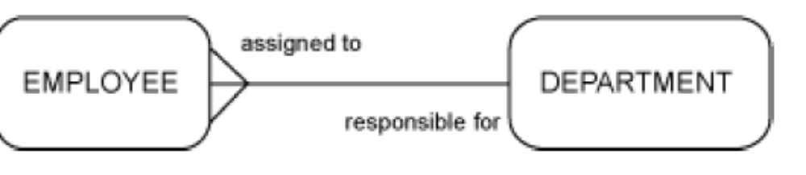ANSWER: _____

- Each EMPLOYEE may be assigned to one or more DEPARTMENTs.
Each DEPARTMENT must be responsible for one or more EMPLOYEEs.

B. Each EMPLOYEE must be assigned to one and only one DEPARTMENT.
Each DEPARTMENT must be responsible for one or more EMPLOYEEs.

- Each EMPLOYEE must be assigned to exactly one DEPARTMENT.
Each DEPARTMENT may be responsible for exactly one EMPLOYEE.

2. In the diagram from question #1 What are the symbol(s) for cardinality.

3. List 2 Relationship sentences between Camera and Photograph. (see diagram below)

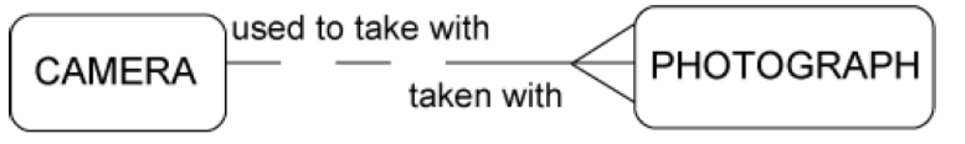
Name 2 Relationship sentences:

A Camera __________ take _________ Photograph(s).

A Photograph ________ be taken by ________ Camera(s).

